Training
Warm Space volunteers are able to use Stroud District Council’s online learning portal. Short courses include Safeguarding, GDPR and Health & Safety. The application form is via the link here:
stroud.melearning.university/user/self_register

Enter your personal details and the information as below

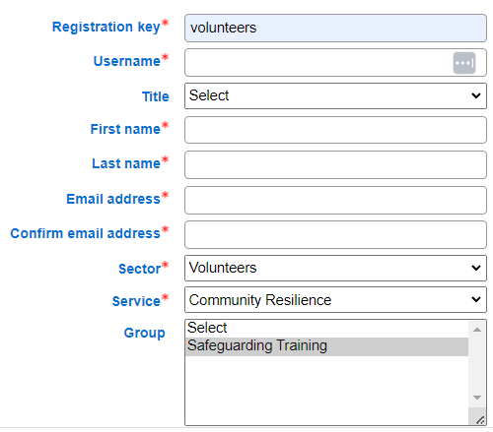

- Registration key: volunteers  - Sector: volunteers | - Service: community resilience  - Group: safeguarding training
After registering, you may receive a message saying there are compulsory courses. Please ignore this.
- Choose 'Courses' from the menu, followed by course library.
- Scroll down to the course you want, click on the 'details' box on the far right and then choose 'enrol'

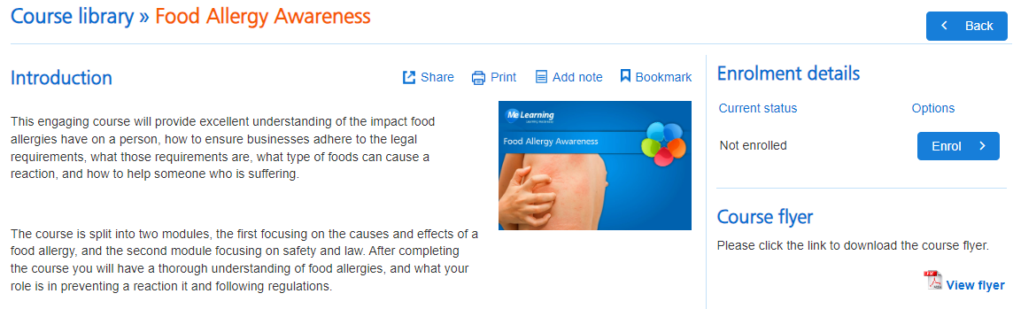

Courses
These course below may be useful.

Food Safety and Hygiene Essentials | 15 mins | stroud.melearning.university/user/course_library/course_details/25
Food Allergy Awareness | 45 mins | stroud.melearning.university/user/course_library/course_details/24
Health and Safety  in the Workplace | 2 hrs 15 | stroud.melearning.university/user/course_library/course_details/33
GDPR  Core for Staff | 1 hour | stroud.melearning.university/user/course_library/course_details/30
Safeguarding (Awareness) | 1 hr 30 | stroud.melearning.university/user/course_library/course_details/59
Safeguarding  Children - Level 1 | 2 hrs 15 | stroud.melearning.university/user/course_library/course_details/75
Safeguarding  Adults - Level 1 | 2 hours | stroud.melearning.university/user/course_library/course_details/56

